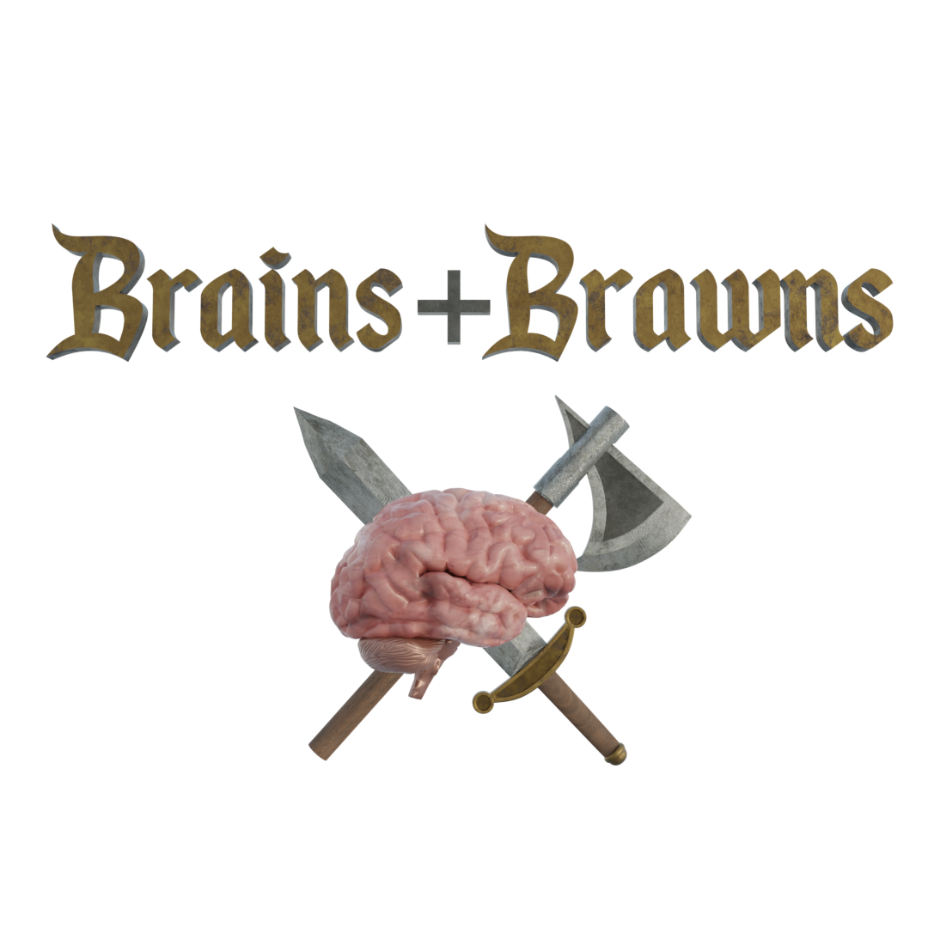

Brains Brawns

Brains + Brawns is a riddle-solving and turn-based combat role-playing game designed for students interested in data science.

This game will be played by a team of 3 people, each of whom will pick one of 3 classes – Knight, Archer, and Wizard. Each class has a weapon type that will make them stronger against certain enemies. Based on their class, each player will get a weapon prop and another prop to signify their class.

The team will be assigned a series of riddles that will lead them to various hidden locations throughout the Christ University campus.

There they will be met with dangerous enemies like the Sphinx (The Greek God Of Riddles), Mimir (The Norse God of Knowledge), and more. These enemies will ask them perplexing riddles the answers to which can only be found by applying knowledge of the subjects of Data Science. The team will have a total of 3 attempts to answer this riddle correctly, if they fail to answer it, they must battle the enemy using the weapons and moves they receive based on their class type.

The combat system is a simplified version of the popular board game Dungeons & Dragons. Its rules are:

* In the first round, all players and enemies involved roll a 20-sided dice to determine their turn in coming rounds of combat.
* When it is the player’s turn, they can choose to either attack the enemy, guard themselves from an oncoming attack or use a healing item to restore their health points.
* Each player, based on their class, can perform a specific type of attack on the enemy; some types of attacks are more powerful on some enemies. For example, a magic attack from a wizard will deal extra damage to a mana-sensitive enemy.
* The players must use their moves wisely to deplete the enemy’s health points before the enemy can defeat them. If they are successful, they will receive the riddle to locate the next hidden location.
* If a player’s health points run out, they must exit combat and can only be active once the combat encounter is over.
* If all members of a team run out of health, that means they have lost the whole game and cannot proceed further.
* A dungeon master (DM) will be present at all combat encounters to help players understand the rules and ensure fair play.

At the end of their journey, the team will receive prizes based on whether they only used their brains (by solving all riddles correctly), or they used only brawns (their combat weapons) or a combination of both to emerge victorious!